**2024 SAFETY SUMMIT**

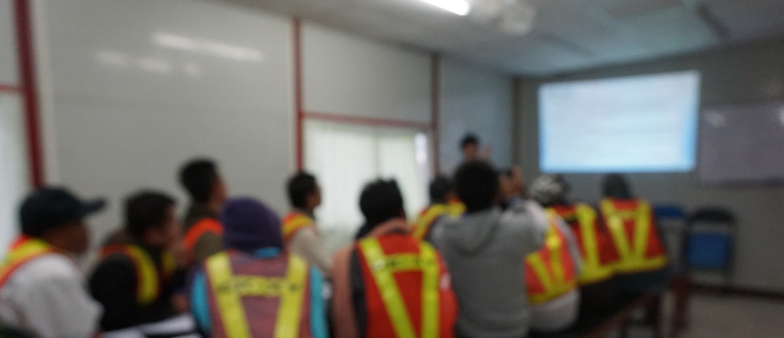

**TY SUMMIT• 2024 SAFETY SUMMIT • 2024 SAFET**

**BE EMPOWERED AND ENERGIZED!**

**LEAD OTHERS TO VALUE SAFETY AS AN ESSENTIAL PART OF DOING BUSINESS!**

[**www.crasif.org**](http://www.crasif.org/)



# *OR* REGISTRATION:

**Scan here &  
reserve a spot.**

# https://www.eventbrite.com/e/crasif-2024-safety-summit-tickets-817178020457

**2024 SAFETY SUMMIT**

This is an 8-hour program using both large and small group interactions that will increase attendees’ health and safety knowledge.

**PROOF**

Summit Theme: *Safety Foundations*

## Specific Attendee Outcomes:

* How do you know your safety program is working? Leading and lagging indicators around road commission activities safety.
* Start. Stop. Continue. Take a critical look at our safety program using case studies.
* What’s next? The importance of lessons learned using leading indicators in our safety programs.

When: Thursday, April 4th and Friday, April 5th

Where: Treetops Resort | 3962 Wilkinson Rd. | Gaylord MI 49735

Attendees: This program is for road commission employees who want to expand their knowledge of leading and lagging indicators around road commission activities.

**THURSDAY, April 4, 2024** *(Lunch on your own)*

# FRIDAY, April 5, 2024

**1:00 – 4:00 pm ……….** Training Session, 15-minute break

**5:00 – 6:00 pm ……………………………….** Social Hour, Cash Bar

**6:00 – 7:00 pm .…..** Dinner provided *courtesy of CRASIF*

**7:00 pm ……………………………………………** Special Activity

**7:00 – 8:00 am ….** Breakfast provided *courtesy of CRASIF*

**8:00** **– 11:30 am** Training Session, 15-minute break

**11:30 – 12:00 noon ……………………………** CRASIF, Program Ends

*(Lunch on your own)*

This program is FREE to CRASIF Member Road Commissions.  
Road commissions are responsible for their lodging and travel costs.

If you have questions, contact Janet Wise at either jwise@crasif.org or **517.371.7880**.